**Interaction Design Lab – Week 11**

**Name: Nguyễn Duy Ân**

**Student ID: 2162372**

This in-depth activity continues the work begun on the booking facility introduced at the end of Chapter 11 (week 06).

* + 1. Assume that you will produce the online booking facility using an agile approach.
  1. Suggest the type of user research to conduct before iteration cycles begin.

- Discount for users booking more than 5 people (including children).

- Create a VIP account for users to use international card payments.

- Have a gifts for customers in the summer when accompanying children.

- Reservations for guests over the age of 60 are offered 1 gift.

-> Take the survey in three months with what age booking.

🡪 product analysis -> development -> testing -> and user evaluation.   
b) b. Prioritize requirements for the product according to business value, in particular, which requirements are likely to provide the greatest business benefit, and sketch out the UX design work you would expect to perform during the first four iteration cycles, that is, Cycle 0 and Cycles 1 to 3

* + 1. Using one of the mock-up tools introduced, generate a mock-up of the product’s initial interface, as developed in the assignment for Chapter 12 (week 07).

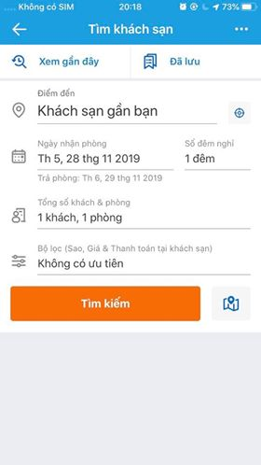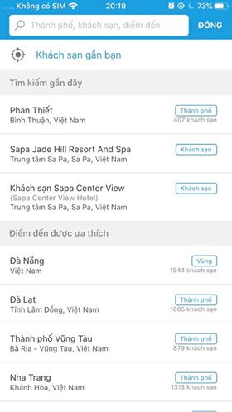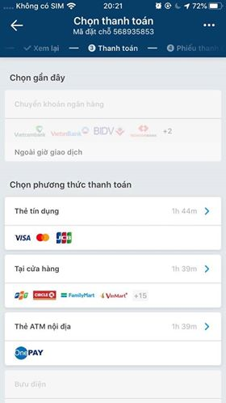

* + 1. Using one of the patterns websites listed previously, identify suitable interaction patterns for elements of the product and develop a software-based prototype that incorporates all of the feedback and the results of the user experience mapping achieved at the end of Chapter 12. If you do not have experience in using any of these, create a few HTML web pages to represent the basic structure of the product.

